
CSI3105 Software Testing
Workshop 8: Combinatorial Testing
Tasks from this workshop must be completed. Some of these tasks will contribute to your ability to complete the Assessments.
Related to Learning Outcomes:
- Apply different test case design techniques, recognising the strength and weakness of each and being able to choose techniques appropriately.
Learning outcomes:
- To develop test cases using combinatorial test design
This workshop covers:
- Combination test design techniques
- Suppose that program P has three input variables A, B, and Y. Let us say that during an execution of P, A, B, and Y may each assume a value from the set {a, b, c}, {d, e, f, g}, and {-2, -3, 0, 1} respectively.
  - List the number of factors and levels for each factor.
  - Calculate the total number of factor combinations
  - List the complete set of the combinations

- Consider the following software with input parameters: D {L, P, C, W, Z}, M {10, 20, 30} and F {Y, N}. Create test cases combinations for pairwise testing (the outputs are not provided, so actual test cases can not be created).

- The table below shows information associated with an internet-based software system, W.

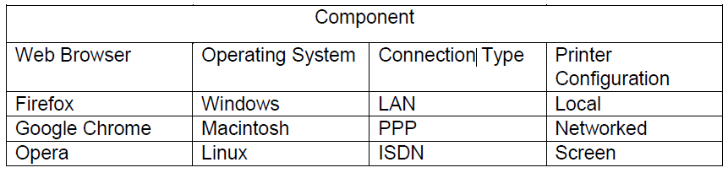

  - List the configuration space of W.
  - How many test configurations would you need to test all possible interactions for this system?
  - Generate test cases to cover all pairs of interaction.

- Using the information in the table, which lists the inputs (with their possible values) for a program:
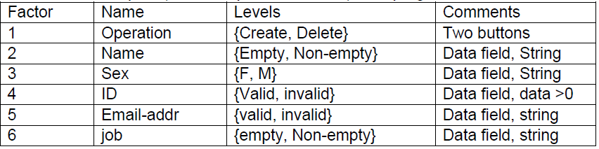
- Generate a test suite to cover all pair-wise interactions using the approach known as SAMNA (as described in the CSI3105_Workshop8-info-bk1.pdf, which has been explained in the SAMNA video for this module).

